**Task Management System - Architecture**

*Created by Marcelo Nespoli Santos*

*Last Updated 16/02/2020*

**Overview of the solution**

The Task Manage Service will be designed to manager any task and will be made of the following main elements:

1. Client Web Application
2. CRUD API Endpoint
3. Report API Endpoint

**Component Diagram**

The purpose of a component diagram is to show the relationship between different components used by a service.

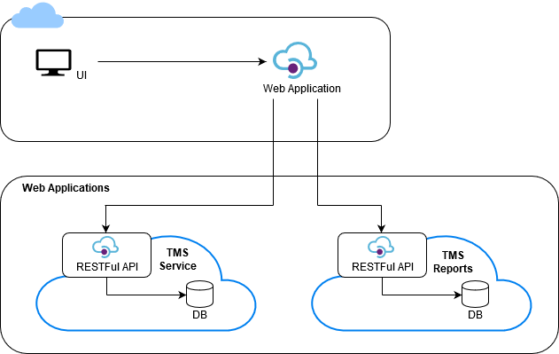

|  |  |  |
| --- | --- | --- |
| **Component** | **Capabilities** | **Description** |
| UI | User interface to manager the tasks | It is an user interface to manager the tasks |
| TMS Service | Manager the tasks and subtasks | It is a back-office web application that allows to define tasks |
| TMS Reports | Provide reports to manager the tasks | It is the reports web application that allows export data from the DB |

**Layers**

|  |  |
| --- | --- |
| **Client** |  |
| **Software Standard** | HTML, Angular |
| **Application Software** | Supported browser are:  MicrosoftInternet Explorer 11 and EDGE  Safari 10.0 and above  Google Chrome Mozilla FireFox on Windows 8.1 and above  MacOS 10.0 and above |
| **Operations Software** | Independent |

|  |  |
| --- | --- |
| **Access** |  |
| **Software Standard** | Http |
| **Application Software** | Azure App Services |

|  |  |
| --- | --- |
| **Presentation** |  |
| **Software Standard** | HTML, JS, Bootstrap 4 |
| **Application Software** | Front-end in angular |
| **Operations Software** | Azure Cloud |

|  |  |
| --- | --- |
| **Business** |  |
| **Software Standard** | C# |
| **Application Software** | .Net Core 2.2 |
| **Operations Software** | Azure Cloud |

|  |  |
| --- | --- |
| **Persistence** |  |
| **Software Standard** | Relational SQL DB |
| **Application Software** | SQL Server equal or greater than 2012 version |
| **Operations Software** | Azure Cloud |

**Data Base**

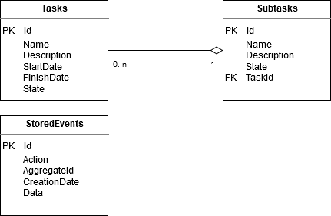

**Request Pipeline**

